**ATAR Physics 11**

**Unit 2**

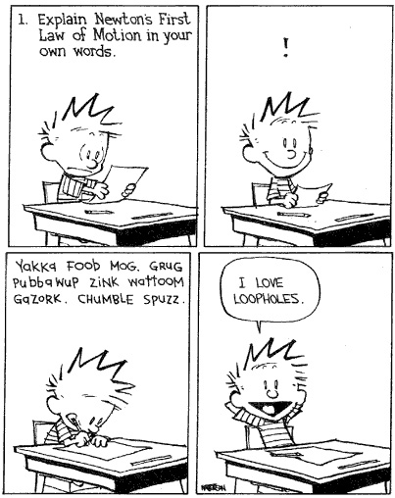

**Linear Motion and Force - 2**

**NEWTON’S LAWS OF MOTION**

Newton’s three Laws of Motion describe the relationship between the force or forces acting on an object, modelled as a point mass, and the motion of the object due to the application of the force or forces

**Newton’s First Law of Motion – Inertia**

* Newton’s First Law of Motion states that *a body will not change its state of rest or motion unless acted on by a net external force.*

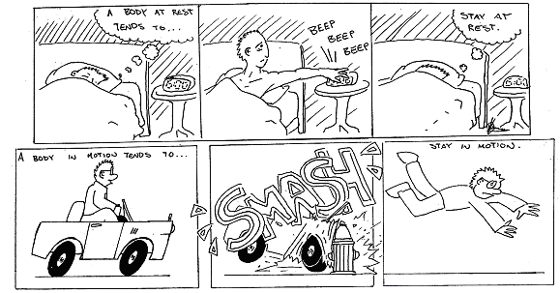

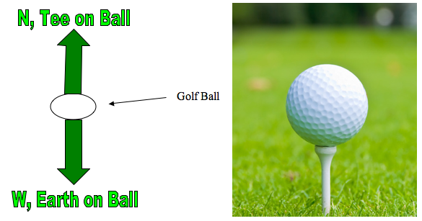

* An object at rest will stay at rest.
* Sum of all the forces equals zero.
  + No net force.
* An object at rest will stay at rest.
* Sum of all the forces equals zero.
  + No net force.

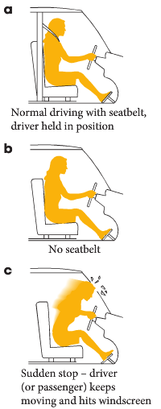

* Now a net force acts to stop the motion.
* *This resistance to change is called inertia.*



* Explain how these cartoons illustrate Newton’s First Law.

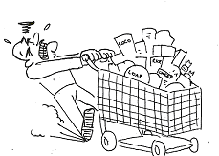

1. Shopping trolley:

____________________________________________________________________________________________________________________________________________________________________________________________

1. 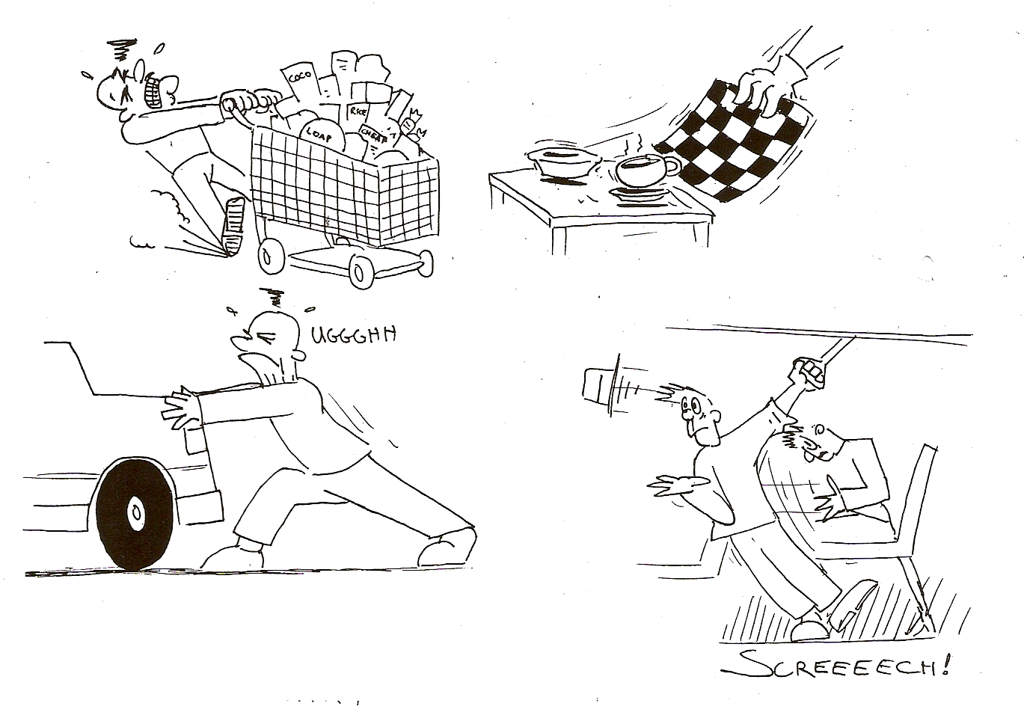Pulling tablecloth out from under china:

_______________________________________________________________________________________________________________________________________

_____________________________________________

NOTE: this can only be done with china not with plastic, why is that so?

_____________________________________________________________________________

_____________________________________________________________________________

1. 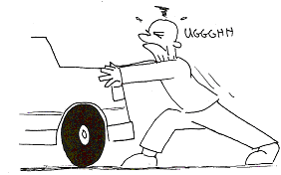Trying to push car:

__________________________________________________________________________________________________________________________________________________________________________________________________________________________

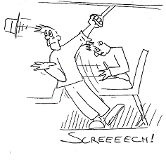

1. Passengers in a bus:

______________________________________________________________________________________________________________________________________________________________________________________________________________________________________

###### Mass And Inertia

* Mass is the amount of matter that something is made of, mass doesn’t change unless you remove some of the matter.
* Inertia is a property of an object that resists change in movement.
* Mass and inertia are closely related. The more mass something has, the harder it is to change its movement so the more inertia it has.
* If one object has twice the mass of another object, it also has twice the amount of inertia.
* The law of inertia states that no force is required to maintain motion. So why do you have to keep peddling your bicycle to maintain motion when riding somewhere?

_____________________________________________________________________________

* If you were in a spaceship in space and fired a rocket, how much force would have to be exerted on the rocket to keep it going?

_____________________________________________________________________________

* In the cabin of a jetliner that cruises at 600 kmh-1, a pillow drops from an overhead rack to your lap below. Since the jetliner is moving so fast, why doesn’t the pillow slam into the rear of the jet?

_____________________________________________________________________________

* Suppose you place a ball in the middle of the floor of an empty truck, and then accelerated the truck forward. Describe the motion of the ball relative to (a) the ground (b) the truck.

_____________________________________________________________________________

_____________________________________________________________________________

**PP 8.3 p 254-61 8.3 Review p 262 WSG p105-6**

## NEWTON’S SECOND LAW OF MOTION

* Consider an object sitting on a table.
* According to Newton’s First Law, the book will stay there until a net external force is added.
* If the object is pushed (supplied the net external force), the object can move.
* Newton’s Second Law of Motion explains the relationship between the force supplied and the acceleration.
* Newton’s Second Law of Motion states that *the rate of acceleration is proportional to the force supplied and inversely proportional to the mass of the object.* Or more simply,



OR  which is more often stated as F = ma

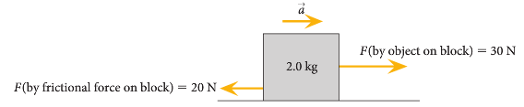

A net force of 10 N acts on the block.

a = 10/2 = 5 ms-2 🡪

* Newton’s Second Law of Motion can also be expressed as follows: *The rate of change of momentum of an object is proportional to the applied force and takes place in the direction of that force.* This can be explained by investigating momentum.

**PP 8.4 p 263-9 8.4 Review p 270 WSG 106-8**

Momentum is a property of moving objects; it is conserved in a closed system and may be transferred from one object to another when a force acts over a time interval

*This includes applying the relationships*



**Momentum**

* Consider two different groups of students are throwing balls to each other.
* One group is using a foam ball, the other group a cricket ball.
* Both are about the same size but if the cricket ball were to hit a window the window could break however the foam ball, thrown at the same velocity, could not break the window.
* The difference is due to the effect of momentum which is the mass of an object times the velocity of that object

p = mv where p = momentum in kgms-1 ; m = mass in kg ; v = velocity in ms-1

* The cricket ball can have a mass of about 160 g while the foam ball has a mass of about 20 g.
* If both are thrown at 15 ms-1 it is clear that there is a large different in momentum and the cricket ball has a much larger effect on the window.

p cricket ball = mv p foam ball = mv

= 0.160 x 15 = 0.020 x 15

= 2.4 kgms-1 = 0.3 kgms-1

* A 1.500 tonne truck is travelling at 5.00 kmh-1. Calculate the velocity a bike and rider must travel at to have the same momentum as the truck (total mass of bike and rider is 80.0 kg).

**Change in Momentum**

* A person is leisurely riding home on a bike when it starts to rain.
* Quickly, the person increase their velocity to limit the time they get wet.
* Here they have experienced a change in momentum.
* The change in anything is the final minus the initial, so change in momentum = final momentum - initial momentum or

Δp = mv - mu

Example:

While running in the park you are initially travelling at 3.50 ms-1 east. A dog runs out and starts to chase you so you increase your velocity to 6.00 ms-1 east. Assuming that your mass is 60.0 kg, what was your change in momentum?

m = 60.0 kg Δp = mv - mu

u = 3.50 ms-1 = m (v – u) = 60.0 (6.00 – 3.50)

v = 6.00 ms-1  = 60.0 x 2.5

Δp = 1.50 x 102 kgms-1 east

* A change in momentum can also include a change in direction.
* Consider the foam ball hitting the window.
* The window doesn’t break and the foam ball rebounds at the same velocity (assume no loss of energy).
* While the magnitude of the velocity is unchanged, its direction has changed so it is a different velocity and there has been a change in momentum.

Example:

The 20.0 g foam ball hits the window at 15.0 ms-1 north and rebounds at 15.0 ms-1 south. What is the change in momentum?

m = 0.020 kg

u = 15.0 ms-1 north

v = 15.0 ms-1 south

ΔV = (v – u) Δp = m (v – u) = m ΔV

= (15.0 ms-1 south – 15 ms-1 north) = 0.02 x 30

= (15.0 ms-1 south + 15 ms-1 south) Δp = 0.600 kgms-1 south

= 30 ms-1 south

**PP 8.1 p 244**

**Back to Newton’s Second Law of Motion**

* Newton’s Second Law can also be stated that force is equal to the rate of change of momentum,

OR  which is the same as 

* Change in velocity divided by time,  , is acceleration so substituting this into the above equation results in **F = ma** which is the simple way of expressing Newton’s Second Law.

## Impulse

* Anyone who is unfortunate enough to be involved in a car accident will experience a force on them that could cause injury.
* Car designers try to make cars as safe as possible, so to do this they try to decrease the force acting on the passengers.
* In a car accident, the passenger’s velocity changes so they undergo a change in momentum.

 this can be re-written as

FΔt = mv - mu

* **FΔt** is known as impulse (units Ns) and is equal to the change in momentum: Impulse = FΔt

**Change in Momentum and Changing force**

* For any situation where an object comes to a sudden stop, the change in momentum can’t be altered.
* A car travelling at 60 km hr-1 that comes to rest will have the same change in momentum if it hits a tree or slows down slowly using its brakes.
* That means that the magnitude of the impulse can’t be changed.
* However, it is the force on the passenger that car designers are trying to decrease.
* 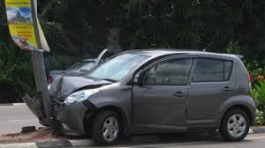While the impulse can’t be changed, the time of the crash can.
* If the time over which a car accident takes place is increased, the force must be decreased.
* To increase the time of the crash, car designers now design cars that crumple – this increases the time for the car to stop in a crash, thus decreases the force and possibly preventing injury.
* However it does often also mean that a small crash can cause crumpling of your car.
* 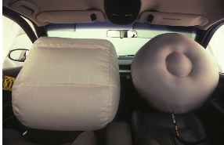Another safety feature inside the car is the air bag.
* These inflate very rapidly and provide a cushion during a collision.
* They are designed to deflate so that the occupants of the car will come to rest over a longer period of time and, therefore, reduce the force on the occupants.
* Seat belts provide two safety features.
  + By Newton’s First Law, they prevent the occupant of a vehicle from continuing on when the vehicle comes to a rapid stop.
  + If the seat belt is **retractable** they also increase the time to come to rest.

### Decreasing Force on you using a Long Time

* If a person is in a car that was out of control would prefer to hit something soft like a haystack than something hard like a concrete wall.
* By hitting the haystack they extend the time of impact – they extend the time during which your momentum is brought to zero.
* The change in momentum will be the same (impulsive is the same), but the longer the time over which the change in momentum occurs, the less the force on the occupants.
* If you extend the time of impact 100 times, you reduce the force of impact by 100.

### Increasing Force on object using a Short Time

* To get the greatest force in a change of momentum situation, then the change must occur over the shortest time.
* Consider a karate expert who can break a stack of bricks with the blow of her bare hand.
* She brings her arm and hand down swiftly against the bricks with considerable momentum.
* This momentum is quickly reduced when she delivers an impulse to the bricks.
* The impulse is the force of her hand against the bricks.
* By swift execution she makes the time shorter and the force of impact huge.
* If she also reverses the velocity of her hand when she hits the bricks then the change of momentum will be even further increased.

**PP 8.2 p 251-3 8.2 Review p 253 8.6 p 277-85 8.6 Review p 286 WSG p109-2**

* People often put ‘roo bars’ on the front of their cars.

1. What is the purpose of this? __________________________________________________
2. How does this affect the safety aspect of the car in a crash?

_____________________________________________________­___________________________

________________________________________________________________________________

________________________________________________________________________________

* Why do you move your hand away from a high-speed ball upon contact instead of towards the ball?

_____________________________________________________­___________________________

________________________________________________________________________________

________________________________________________________________________________

* Why do they have sand under playground slides instead of concrete?

_____________________________________________________­___________________________

________________________________________________________________________________

Example:

A person is running in the park, initially travelling at 3.50 ms-1 east when a dog started to chase them and they increased their velocity to 6.00 ms-1 east. Assuming that their mass is 60.0 kg and that the change of momentum happened in 1.50 s, what force was applied to increase their velocity?

m = 60.0 kg

u = 3.50 ms-1

v = 6.00 ms-1

t = 1.50 s

F = 1.00 x 102 N

* While cycling along Selby Street you apply the brakes to stop in 8.70 m to avoid hitting a car backing out of a driveway. You are moving at a speed of 36.0 kmh-1 and the total mass of your bicycle and you is 76.0 kg. Calculate the force exerted by the brakes, the change in momentum and then the impulse you experience.
* A 1.50 tonne car is travelling at 72.0 kmh-1, experiences a force of 1.00 x 104 N for 0.800 s when the brakes are applied. What is its final velocity?

#### Conservation Of Momentum

* If you fire a high-speed rifle there is recoil, as the bullet goes forward, the gun moves back.
* The law of conservation of momentum states that; *in the absence of an external force, the momentum of a system remains unchanged.*
* In any collision:

net momentum after collision = net momentum before collision

Ensure directions are right.

ρafter = ρbefore

m1v1 + m2v2 = m1u1 + m2u2

* Two gliders on an air track are moving towards each other. Glider one has a mass of 3.00 kg and is travelling right at 4.0 ms-1. Glider two has a mass of 5.00 kg and is travelling at 2.00 ms-1 left. After they collide elastically, glider one rebounds with a velocity of 6.00 ms-1 to the left. What was the second glider’s velocity? (Remember, if the direction changes, so does the sign in front of the velocity.)

* Tim is playing with his toy cars. Car 1 has a mass of 1.20 kg and car 2 has a mass of 0.800 kg. He pushes car 1 with a constant velocity of 1.50 ms-1. He then pushes car 2 with a constant velocity of 2.25 ms-1 and lets go so that it ramps into the back of car 1. If they then stick together, with what velocity will both cars continue to move with after the crash. Assume no friction.

**PP 8.1 p 245-50 8.1 Review p 250 EP Prob Set 17 p164 WSG p113-6**

**NEWTON’S THIRD LAW OF MOTION – ACTION / REACTION**

* Newton’s Third Law of Motion states that *for every force applied (action), an equal and opposite force always appears (reaction), even if no movement results.*
* The most important aspect of Newton’s Third Law is to be aware of the fact that there are TWO different forces acting.
* While the value is identical, the directions are reverse so they are different forces.
* The forces act on different objects, NEVER on the same one, so the forces can’t cancel each other out.

e.g. body A exerts a force on B – ACTION body B exerts a force on A – REACTION

* Kicking a ball: A common misunderstanding of Newton’s Third Law – if I kick a ball, the ball can’t move as action/reaction forces are the same. But if the ball is kicked it accelerates.
* The only force on the ball is the kick, so it can accelerate, the reaction force acts on your foot and slows it down – that is the force from the ball on your foot.

**PP 8.5 p 271-5 8.5 Review p 276 WSG p112-3**

* Why do cars move?

________________________________________________________________________________

Action force: ­___________________Reaction Force: ___________________

* Why do objects fall to earth?

________________________________________________________________________________

Action force: ­___________________Reaction Force: ___________________

* A bug hitting the windscreen of a bus slows the bus down.

_____________________________________________________­___________________________

Action force: ­___________________Reaction Force: ___________________

Free body diagrams show the forces and net force acting on objects, from descriptions of real-life situations involving forces acting in one or two dimensions

*This includes applying the relationships*



**FREE BODY DIAGRAMS**

* In solving problems, it is sometimes useful to illustrate on a diagram all the forces that are acting on the object.
* This type of diagram is called a **free body diagram**.
* Arrows will show the direction of the force and the length will show the size of the force relative to other forces shown on the diagram.

Basically:

1. Is there gravity? This will be downwards. Fg
2. Is the object on a surface? Upward normal force for gravity. FN

Generally these two forces are the same length unless the object is ascending or descending.

1. Is something pushing or pulling. This is the forward action force. FA
2. Is there friction. This is the force that retards the motion. Ff
3. Is the object accelerating. Positive acceleration then FA arrow larger than friction, negative acceleration then FA arrow is shorter than friction.

Let’s consider Samuel who is riding his bike along a straight road at a constant velocity. For this particular situation consider the following forces that are acting on Samuel: *weight, reaction force from road, forward motion* and *frictional forces (including air resistance).* As his velocity is constant, forces up must equal forces down and forces right must equal forces left:

*Reaction force road*

*FN*

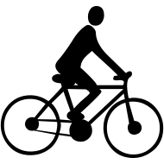

*FA Forward motion*

*Friction Ff*

*Fg Weight*

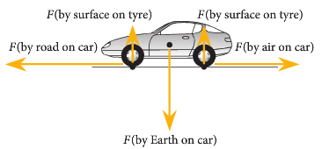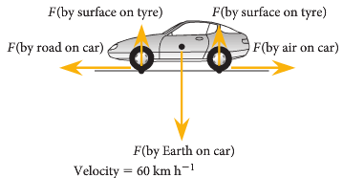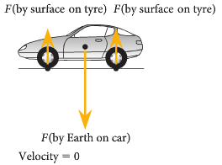

**Σ**F = 0 **Σ**F = 0 **Σ**F = ma

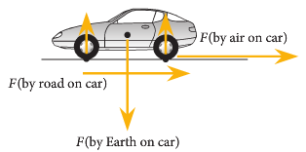

**Σ**F = -ma

* A driver places a large heavy box in the middle

of the tray of a delivery truck. The box is not tied down.

On a diagram show all the major forces acting on the

box as the truck accelerates. Use labelled arrows to

show their direction and related size of each force.

* On the right, draw a skydiver who has just opened his parachute.

**WSG p103-4**

**More on Newton’s Second Law**

* From Newton’s Second Law, it has been established that if a net force acts on an object then it will cause the object to accelerate.
* A net force is the sum of all the forces acting and this is what causes the acceleration.

**ΣF = ma**

* Most problems will only have one force acting and will cause motion in the direction of the force.
* Here are some other situations.

**Forces at an angle**

* **Components of a Force**.
  + **Forces** acting at some angle from the horizontal can be resolved into mutually perpendicular **forces** called **components**.

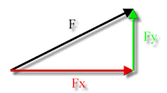

**θ**

* + The **component of a force** parallel to the x-axis is called the x-**component**, parallel to y-axis the y-**component**, and so on.
  + These components can be evaluated using trig.
  + Fy = F sin**θ**
  + Fx = F cos**θ**

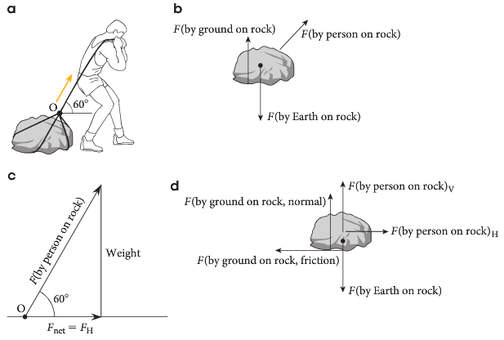

* If an object is at rest, ΣF = 0.
  + ΣFup = ΣFdown
  + ΣFleft = ΣFright
* If an object is moving at constant velocity, ΣF = 0.
* Otherwise, the object must be accelerating.
  + ΣF ≠ 0
  + ΣF = ma

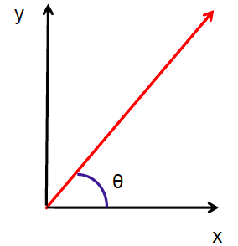

* An object is projected into the air with a velocity of 35.0 ms-1 at an angle of 40.0 **°**. Calculate the vertical and horizontal components of the velocity

**Objects on a sloped surface**

* R is the reaction force from the ground.
* mg is the weight of the object.
* If no friction is acting, the two forces can be added together to find the net force.

θ

mg

R

**Fnet**

* The weight force can be resolved into two components.
* The force that pulls the object down the slope is F∥= mg sinθ.
* The acceleration down the slope is a = g sinθ.
* If there is any friction acting, it will oppose the force.
* F⊥ = mg cosθ = R

mg

mg cosθ

mg sinθ

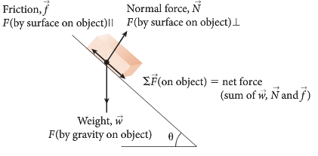

* If friction is acting, it will always oppose the motion.
* A 5.0 kg mass slides down a frictionless plane inclined at 30**°** to the horizontal. Calculate
  + 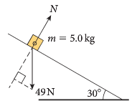The force applied by the surface to the mass.
  + The force that causes the mass to slide down the slope.
  + The acceleration down the slope.

* A 1.00 kg plastic crate slides down a 19.0**°** at a rate of 2.30 ms-1. Find the force of friction.

**Weight**

* We already know that mass is the amount of matter an object has, it can’t be changed unless matter is added or removed.
* What can be changed is the weight.
* Weight is the mass of a body acted on by acceleration due to gravity.

as F = ma where Fw = weight (N)

and g = a m = mass (kg)

then Fweight or Fw = mg g = acceleration due to gravity (g)

Example:

A 10.0 kg stone is first held on Earth (g = 9.8 ms-2) and on the moon (g = 1.6 ms-2). What is its weight in both cases?

Fw Earth = mg = 10 x 9.8 Fm Moon = mg = 10 x 1.6

Fw Earth = 98 N Fw Moon = 16 N

**PP 8.7 p 287-9 8.7 Review p 290 Chapter review p 291-2 WSG p115-7**

## Going Up and Down

* Why do you feel heavier or lighter when a lift starts or stops?
* 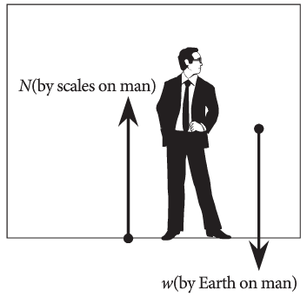Your acceleration (from the lift) is added vectorally to the acceleration due to gravity.
* When you are stationary or moving at a constant velocity, there is no net force acting on you.
* The force up (reaction force or normal force, N) is provided by the floor and is the measurement on the scales.
* The force down is due to weight, w. (w = mg)
* In this case, the force up, N, is equal the force down, w.
* ΣF = ma. Since a = 0, ΣF = 0. N = w
* **∴** N = mg
* When you accelerate up, gravity must be overcome so your apparent weight is

N = m (g + a) *you feel heavier*

* + Upward acceleration occurs when a stationary lift takes off upwards or when a descending lift comes to a stop.
  + Take up as positive.
  + ΣF = ma. N – w = ma
  + **∴** N = ma + mg N = m(a + g)

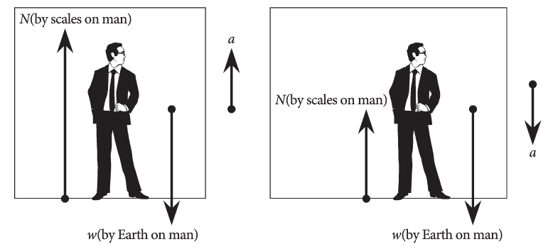

* When you accelerate down, the acceleration is helping gravity, so your apparent weight is

N = m (g – a) *you feel lighter*

* + Downward acceleration occurs when a stationary lift takes off downwards or when an ascending lift comes to a stop.
  + Take down as positive.
  + ΣF = ma. N – w = ma
  + **∴** N = ma + mg N = m(a + g)
* When you are moving at a constant velocity, there is no additional acceleration so your weight is simply Fw = mg

* A 40.0 kg boy is playing in a lift. Calculate his weight in the following circumstances:

a.before he gets into the lift. b. when the lift accelerates up at 3.00 ms-2.

c. when the lift is travelling at 5.00 ms-1 d. when the left decelerates at 3.50 ms-2

* As part of the construction of a skyscraper, a large industrial crane is lifting 250 tonnes of steel girders up the side of the partly completed building. Calculate the apparent weight of the steel in each of the following situations.
  + - * 1. The crane initially lifts the steel off the ground with an acceleration of 1.60 ms-2.

**Fw = m (g + a) = 250 x 103 x (9.8 + 1.60) = 2.85 x 106 N**

* + - * 1. The steel is then lifted upwards at a constant velocity of 1.25 ms-1.

**Constant velocity so no additional acceleration; Fw = mg = 250 x 103 x 9.8 = 2.45 x 106 N**

* + - * 1. On reaching the required floor, the crane decelerates at 1.42 ms-2

***Fw = m (g – a) = 250 x 103 x (9.8 – 1.42) = 2.095 x 106 N***

* + - * 1. Having unloaded the steel, the crane’s 50.0 kg hook descends rapidly downwards with an initial acceleration of 4.80 ms-1.

**Fw = mg = 50 x (9.8 – 4.8) = 250 N**

**Tension in strings**

**1. Pulleys**

* An object is tied to a rope and this rope is threaded through a smooth pulley and connected to another object, as shown.

Each object will have a force due to gravity = weight.

Both objects will accelerate in the direction of the heavier mass.

ΣF = ma. a will be the overall acceleration of the system.

There will be tension in the rope due to the weights of the objects. The tension must be the same in both sides of the rope.

Example:

An 1150 kg elevator is connected to a 1000 kg counterweight via a frictionless pulley.

1. Calculate the acceleration of the elevator.

1150 kg

1000 kg

ΣF = ma

mg – mg = ma

1150 x 9.8 – 1000 x 9.8 = 2150 x a

a = 0.684 ms-2 in the direction of the elevator.

1. Calculate the tension in the cable.

Draw a free body diagram of either mass. Do the same for the other mass.

T

mg

1000 kg

ma

T – mg = ma

T = ma + mg

= 1000 x 0.684 + 1000 x 9.8

= 10 484 N

= 10 500 N

* A monkey of mass 15 kg jumps onto a very light rope connected to a 10 kg mass. Calculate the acceleration of the monkey and the tension in the rope.

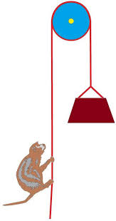

1. **Towing**

When object are towed along, the acceleration of the whole system is calculated from the net force and the total mass.



The tension in any attached ropes will be less in the ropes away from the external force.

* Two boxes, A and B, are connected by a cord. A person pulls horizontally on box A with a force of 40.0 N.

40.0 N

12.0 kg

Box A

Box B

10.0 kg

a) Draw a free body diagram of the forces on box A.

b) Find the acceleration of the boxes.

c) Find the tension in the cord connecting the box.

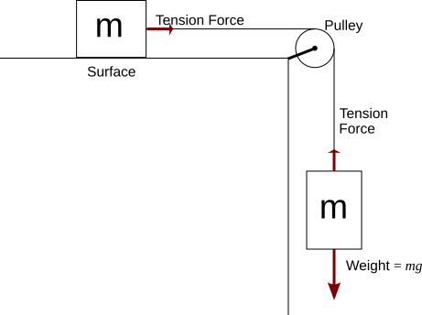

* A 10 kg mass is resting on a smooth horizontal surface and connected to a light string over a pulley to another mass of 4 kg that hangs vertically.

Find the acceleration of the system, the tension in the

string and the net force on each mass .

* m1 and m2 are placed on a sloped surface as shown. Each mass is 2.7 kg. If a frictional force of 3.60 N is applied to m1, determine the acceleration of the system.

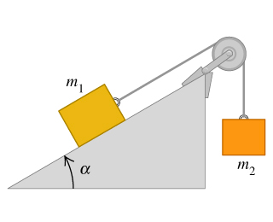

**Some Commonly Asked Conceptual Questions on Newton’s Laws**

1. Explain the process of walking in terms of Newton’s Laws of Motion. Why do you slip on a wet, highly polished floor?
2. If a large Mack truck and a small Volkswagen car have a head-on collision, which vehicle will experience the greater impact force? Explain your answer.
3. It is now law that all cyclists should wear a crash helmet. How exactly does a crash helmet reduce head injury in the event of a crash?
4. While pushing his baby sister in her pram, Ben notices that he needs to push harder when he is going up a grass slope compared to the bitumen road. The slope of the grass and the road is about the same. What explanation do you give to Ben?
5. In many cars, air bags are a safety feature. When there is a collision, sensors in the car trigger an air bag to inflate. This air bag is a large balloon inflated from the centre of the steering column. This bag prevents the driver’s head from hitting the steering wheel.

Explain in terms of impulse and change in momentum, why air bags are recommended to reduce facial injuries during car collisions.

1. (a) When you ride your bike at full speed, which has the greater momentum – you or the bike?

Explain.

1. If you are riding a bike and stop suddenly, you are likely to go over the handlebars. Why?
2. When catching a ball, your cricket coach advises you to move your hands backwards. Explain the physics behind this “follow through” technique.
3. For a party trick, Lee balances a small square of cardboard on a glass. A ten cent coin is placed on the card. When one corner of the card is flicked it moves leaving the coin behind to fall into the glass. Explain why this happens and which law this phenomenon is associated with.

Energy is conserved in isolated systems and is transferred from one object to another when a force is applied over a distance; this causes work to be done and changes the kinetic ( Ek) and/or potential (Ep) energy of objects

*This includes applying the relationships*



**ENERGY, WORK AND POWER**

* The universe can be thought of as made up of matter and energy, with energy being required to move the matter.
* Matter is a relatively easy concept to grasp as it has mass, it occupies space, and it can be seen, heard, felt and sometimes smelt.
* Energy however is more abstract, although it does have various familiar forms such as heat, light, sound and electrical energy.

**Work**

* In everyday speech, ‘work’ has a variety of meanings.
* In science, however, ‘work’ has a clearly defined definition in Physics.
* Work is done only when a force (in Newtons) makes an object move over a distance (in metres).
* So when, for instance, you push a lawn mower over a lawn you make it move and you do work.
* If you push on something and do not move it, or hold a heavy object stationary, no work is done.
* Therefore:

Work = force x displacement

W = Fs

* The unit of work is the joule (J). One joule of work is done if a force of 1 Newton moves an object through a displacement of 1 metre in the direction of the force.

Example:

If we were to push the family car along the driveway into the garage, a distance of 12.0 m, by applying a constant horizontal force of 2.50 x 102 N, the work done is:

s = 12.0 m W = Fs

F = 250 N W = 12 x 250

W = 3000 = 3.00 x 103 J

* Two boys are using a force of 1.00 x 102 N to move a bed 3.00 m across a bedroom. What is the work done?
* What work is required to lift a 5.00 kg bag of potatoes from the floor to a shelf 1.50 m above the ground?

**WSG p118**

**Energy**

* Work and energy are related.
* Energy can be defined as *the capacity to do work*.
* Whenever work is done, some energy is transferred from one object to another.
* The unit of energy is the same as that of work, namely the **joule (J).**

**PP 9.1 p 294-301 9.1 Review p 302-3**

**Kinetic Energy**

* Kinetic energy is the energy an object has because it is moving.
* A moving car has kinetic energy whereas a stationary car does not.
* The faster an object moves, the greater its kinetic energy.
* Also the greater the mass of the object, the greater its kinetic energy.

Ek = ½mv2 Ek = kinetic energy (J)

m = mass (kg)

v = velocity (ms-1)

Example:

A car of mass 1.50 tonne is moving at 20.0 ms-1. What is its kinetic energy?

Ek = ½mv2

= 0.5 x 1500 x (20)2

= 3.00 x 105 J

* A man is running at 5.00 ms1 and using 937 J of energy, what was his mass?

**PP 9.2 p 304-7 9.2 Review p 308**

**Gravitational Potential Energy**

* A car at the top of a hill has energy because of its position.
* If allowed to roll down the hill, the car could do work because it could exert a force on another object and hence move it.
* The energy an object has because of its height above Earth, is (gravitational) potential energy.

Ep = mgh Ep = potential energy (J)

m = mass (kg)

g = acceleration due to gravity (ms-2)

h = height above earth (m)

Examples:

What is the potential energy of a small car of mass 1.00 x 103 kg at the top of a hill of height 50.0 m?

Ep = mgh

= 1000 x 9.8 x 50

= 4.90 x 105 J

* A ball is thrown into the air. Just before it starts its downward journey (velocity equal to zero) it is at a height of 2.50 m above the ground. If it has a mass of 0.500 kg, what is its potential energy?

**PP 9.4 p313-6 9.4 Review p 317 WSG p119**

**Law Of Conservation Of Energy**

Energy is conserved in isolated systems and is transferred from one object to another when a force is applied over a distance; this causes work to be done and changes the kinetic ( Ek) and/or potential (Ep) energy of objects

*This includes applying the relationships*



* Kinetic energy and potential energy are usually classified as types of mechanical energy. There are many other types of energy.
  + - Name six other forms of energy.
* The amount of energy within a system is constant in all conversions and this is stated in the **Law of Conservation of Energy**: *Energy is neither created nor destroyed, but can be readily converted from one form to another.*
* *Chemical energy* in a car is burned (*thermal energy)* and turned into *kinetic energy.*
* Other energies involved in this system are *light* and *sound* energy released during the explosion of fuel.
* All of these energies together add up to the original energy in the fuel.
* Describe some other energy transformations:

**Energy Transformations Between Kinetic And Potential Energy**

* A car at the top of a hill has potential energy.
* If it starts to roll it loses potential energy and starts to gain kinetic energy.
* By the time it reaches the bottom of the hill it has lost all its potential energy and gained it as kinetic energy (for this section we will ignore other forms of energy involved e.g. heat from friction).

Ep lost = Ek gained

mgh = ½mv2 masses cancel so

gh = ½v2

Example:

A ball is thrown into the air with an initial velocity of 15.0 ms-1. What is the maximum height it can reach?

gh = ½v2

h = 0.5 x (15)2

9.8

h = 11.5 m

* A girl is on a diving board 3.00 m above the water below. With what velocity will she hit the water when she dives?

**PP 9.5 p 318-25 9.5 Review p 326 WSG p120-3**

Collisions may be elastic and inelastic; kinetic energy is conserved in elastic collisions

*This includes applying the relationship*



**Elastic collisions**

* An elastic collision is one in which no kinetic energy is lost during the collision.
* The total kinetic energy of the particles before the collision must equal the total kinetic energy after the collision.
* Momentum is also conserved during these collisions.
  + - A 4.00 kg charged particle moving at 4.00 ms-1 East approaches another particle, of similar charge, with a mass of 2.00 kg moving at 2.00 ms-1 West. The first particle remains stationary while the second particle rebounds at 6.00 ms-1 East.

Show that kinetic energy and momentum are conserved.

**Inelastic collisions**

* An inelastic collision is one in which kinetic energy is lost during the collision.
* The total kinetic energy of the particles before the collision doesn’t equal the total kinetic energy after the collision. Some of it is converted to heat and sound
* Momentum is conserved during these collisions.
  + - A 5 000.0 kg truck, travelling at 4.00 ms-1 runs into the back of a 2 500.0 kg car, which was at rest. The two vehicles stick together.
      * Calculate the velocity of the two cars after the collision.
      * Determine how much energy is lost as heat and sound.

**PP 9.3 p 309-11 9.3 p 312**

Power is the rate of doing work or transferring energy

*This includes applying the relationship*



**Power**

* You can walk up a set of steps quite easily but if you run up the same set of steps you can get very tired.
* In both cases **the same amount of work** is done because you have raised your mass up a certain amount of height and work = Fs or mgs.
* The only difference between the two trips up the steps is the time taken to do the work and this involves the power.
* Power is defined as: *The rate at which we do work* ***or*** *The rate at which we use energy.*
* Explain why these are equivalent statements.

_____________________________________________________­___________________________

________________________________________________________________________________

* Power is calculated as the number of joules of energy used (or work done) per second.



* The **watt (W)** is the unit of power and is equal to one joule per second.
* So the relationships for power are: 

Example:

A boy runs up a staircase in 10.0 seconds. If he uses 1.00 x 103 J of work, what was his power output?

t = 10s P = W

W = 1000 J t

P = 1000

10

P = 1.00 x 102 W

* A girl climbs a 4.00 m ladder in the gym in 8.00 seconds. If her mass if 40.0 kg, what is her power?
* How much power is needed to push a bookcase 3.60 m across a room in 3.00 s if you use a force of 1.50 x 102 N?

**PP 9.6 p 327-9 9.6 Review p 329**

**Work, energy and power:**

1. A car has an initial velocity of 90.0 kmh-1 when it slows to 54.0 kmh-1 in 2.30 s. If the car has a mass of 8.00 x 102 kg, what work was done in slowing the car down?
2. On a day when Beth is late for work, she runs up the 15.0 m high stairs in 8.00 s. When she is on time, she walks up the stairs in 25.0 s. If Beth has a mass of 54.0 kg, discuss the difference in work and power for each trip then justify your comment with appropriate calculations.
3. You throw a 0.100 kg ball downwards with an initial velocity of 2.50 ms-1. If the ball was held 1.20 m above the ground, with what kinetic energy would it hit the ground?

* Consider young Johnny who has a total mass of 60 kg (Johnny and skateboard). If he is moving at 3.4 ms-1 at the top of the 5.0 m high hill, what is his velocity at the bottom?

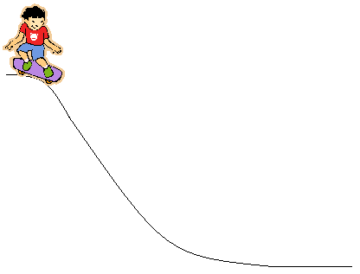

* 200 kg trolley on the top of a hill that follows path as shown. The trolley is initially travelling at 2.0 ms-1 at the top of hill A. Find velocity at B, C and D

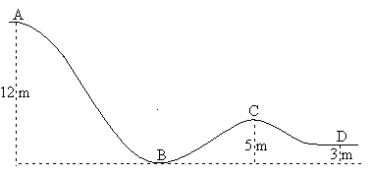

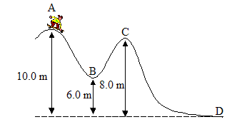

1. A teenager is skateboarding at a skateboard park (the mass of him and the skateboard is 70.0 kg). At one particular part he starts at the top of a 10.0 m hill, point A, which has a drop of 4.00 m before going up again 2.00 m before finally dropping down 8.00 m. The situation is shown in the diagram below. Find the velocity of the skateboarder at points B, C and D. The velocity at point A is zero.

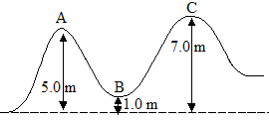

1. The same situation as above in question 5, but this time the skateboarder is moving with an initial velocity of 3.00 ms-1 at point A.

**PP Chapter review p 330-1**

**WSG p124-8 Test 4 p175**

**Work, energy and power:**

1. A car has an initial velocity of 90.0 kmh-1 when it slows to 54.0 kmh-1 in 2.30 s. If the car has a mass of 8.00 x 102 kg, what work was done in slowing the car down?

**Work = change in kinetic energy a = (v-u)/t = (15-25)/2.30 = -4.3 ms-2**

**= Ek (initial) - Ek (final)  F = ma = 800 x -4.3 = -3478N**

**= (0.5 x 800 x 252) - (0.5 x 800 x 152) OR s = (v2-u2)/2a = (152-252)/(2x-4.3) = 46m**

**= 250 000 - 90 000 W = Fs = 3478 x 46 = 1.60 x 105 J**

**= 1.60 x 105 J**

1. On a day when Beth is late for work, she runs up the 15.0 m high stairs in 8.00 s. When she is on time, she walks up the stairs in 25.0 s. If Beth has a mass of 54.0 kg, discuss the difference in work and power for each trip then justify your comment with appropriate calculations.

**Work will be the same because W = Fs. Power however is the rate of doing work. As time is different, the power will be different. Less time means greater power.**

**For both,**

**m = 54 kg W = Fs = mgs**

**g = 9.8 ms-2 = 54 x 9.8 x 15**

**s = 15 m W = 7938 J**

**W = 7.94 x 103 J**

**Walk Run**

 

**P = 318 W P = 992 W**

1. You throw a 0.100 kg ball downwards with an initial velocity of 2.50 ms-1. If the ball was held 1.20 m above the ground, with what kinetic energy would it hit the ground?

**ET = Ep + Ek which at bottom all becomes kinetic energy**

**= (0.1 x 9.8 x 1.2) + (0.5 x 0.1 x 2.52)**

**= 1.176 + 0.3125**

**= 1.4885 J**

**Kinetic energy on the bottom = 1.49 J**

**now all this becomes kinetic energy from which the velocity can be calculated**

**1.4885 = 0.5 x 0.1 x v2**

**v = 5.46 m/s**

* Consider young Johnny who has a total mass of 60 kg (Johnny and skateboard). If he is moving at 3.4 ms-1 at the top of the 5.0 m high hill, what is his velocity at the bottom?

** ET = Ek + Ep**

**= (mgh) + (0.5 mv2)**

**= (60 x 9.8 x 5.0) + (0.5 x 60 x 3.42)**

**= 2940 + 346.8**

**= 3286.8 J**

**now all the energy it turned into kinetic energy so ET = EK**

* 1. **= 0.5 mv2**
  2. **= 0.5 x 60 x v2**
  3. **= 30v2**



**v = 10 ms-1**

* 200 kg trolley on the top of a hill that follows path as shown. The trolley is initially travelling at 2.0 ms-1 at the top of hill A. Find velocity at B, C and D



1. **find total energy of system**

**ET = Ek at A  + Ep at A**

**= (0.5mv2) + (mgh)**

**= (0.5 x 200 x 22) + (200 x 9.8 x 12)**

**= 23 520 + 400**

**= 23 920 J and this value is constant throughout system.**

|  |  |  |
| --- | --- | --- |
| **Velocity at B is like previous**  **ET = Ek at B**  **23 920 = 0.5 x 200 x v2**  **v2 = 23 920 ÷ (0.5 x 200)**  **= 239.2**  **v = 15.5 ms-1** | **Velocity at C**  **ET = EP (c)  + Ek (c)**  **23 920 = (mgh)c + (0.5mv2)**  **23 920 = (200 x 9.8 x 5) +**  **(0.5 x 200 x v2)**  **23 920 = 9800 + 100v2**  **100v2 = 23 920 – 9800**  **= 14 120**  **v2 = 141.2**  **v = 11.9 ms-1** | **Velocity at D**  **ET = EP (c)  + Ek (c)**  **23 920 = (mgh)c + (0.5mv2)**  **23 920 = (200 x 9.8 x 3) +**  **(0.5 x 200 x v2)**  **23 920 = 5880 + 100v2**  **100v2 = 23 920 – 5880**  **= 18 040**  **v2 = 180.4**  **v = 13.4 ms-1** |



1. A teenager is skateboarding at a skateboard park (the mass of him and the skateboard is 70.0 kg). At one particular part he starts at the top of a 10.0 m hill, point A, which has a drop of 4.00 m before going up again 2.00 m before finally dropping down 8.00 m. The situation is shown in the diagram below. Find the velocity of the skateboarder at points B, C and D. The velocity at point A is zero.

**Answer: B: 8.85 ms-1**

**C: 6.27 ms-1**

**D: 14 ms-1**



1. The same situation as above in question 5, but this time the skateboarder is moving with an initial velocity of 3.00 ms-1 at point A.

**Answer: B: 9.35 ms-1**

**C: won’t reach C – only rises 0.460 m**

**Conceptual Questions.**

1. Explain the process of walking in terms of Newton’s Laws of Motion. Why do you slip on a wet, highly polished floor?
2. If a large Mack truck and a small Volkswagen car have a head-on collision, which vehicle will experience the greater impact force? Explain your answer.
3. It is now law that all cyclists should wear a crash helmet. How exactly does a crash helmet reduce head injury in the event of a crash?
4. While pushing his baby sister in her pram, Ben notices that he needs to push harder when he is going up a grass slope compared to the bitumen road. The slope of the grass and the road is about the same. What explanation do you give to Ben?
5. In many cars, air bags are a safety feature. When there is a collision, sensors in the car trigger an air bag to inflate. This air bag is a large balloon inflated from the centre of the steering column. This bag prevents the driver’s head from hitting the steering wheel.

Explain in terms of impulse and change in momentum, why air bags are recommended to reduce facial injuries during car collisions.

1. (a) When you ride your bike at full speed, which has the greater momentum – you or the bike? Explain.
2. If you are riding a bike and stop suddenly, you are likely to go over the handlebars. Why?
3. When catching a ball, your cricket coach advises you to move your hands backwards. Explain the physics behind this “follow through” technique.
4. For a party tick, Lee balances a small square of cardboard on a glass. A ten cent coin is placed on the card. When one corner of the card is flicked it moves leaving the coin behind to fall into the glass. Explain why this happens and which law this phenomenon is associated with.

**Conceptual Questions.**

1. Explain the process of walking in terms of Newton’s Laws of Motion. Why do you slip on a wet, highly polished floor?

**During every interaction, forces always occur in pairs (action/reaction). For example, in walking across the floor you push against the floor and in turn the floor pushes against you (Newton’s Third Law). Walking across a floor depends on friction – when you walk across a slippery floor, you are not able to exert the action force against the floor to produce the needed reaction force due to the reduced amount of friction.**

1. If a large Mack truck and a small Volkswagen car have a head-on collision, which vehicle will experience the greater impact force? Explain your answer.

**The Mack truck and the Volkswagen will experience the same impact force. (Newton’s Third Law).**

1. It is now law that all cyclists should wear a crash helmet. How exactly does a crash helmet reduce head injury in the event of a crash?

**Helmets are designed so that the force of impact is distributed over a large area and the time of impact is increased. Thus the head experiences a reduced force due to Newton’s Second Law: , increase t, decrease F.**

1. While pushing his baby sister in her pram, Ben notices that he needs to push harder when he is going up a grass slope compared to the bitumen road. The slope of the grass and the road is about the same. What explanation do you give to Ben?

**For Ben to push the pram uphill, he has to apply enough force to overcome the force due to the weight as well as to move it. The grass slope has greater resistance so it is harder to push than on the road.**

1. In many cars, air bags are a safety feature. When there is a collision, sensors in the car trigger an air bag to inflate. This air bag is a large balloon inflated from the centre of the steering column. This bag prevents the driver’s head from hitting the steering wheel.

Explain in terms of impulse and change in momentum, why air bags are recommended to reduce facial injuries during car collisions.

**The air bags increase the time to stop thus reducing the rate of change of momentum and hence reducing the force on the hand.**

1. (a) When you ride your bike at full speed, which has the greater momentum – you or the bike? Explain.

**Depends on which has the greater mass as momentum equals mass times velocity.**

1. If you are riding a bike and stop suddenly, you are likely to go over the handlebars. Why?

**The stopping force is acting on the bike. Due to your inertia you would go over the handlebars.**

1. When catching a ball, your cricket coach advises you to move your hands backwards. Explain the physics behind this “follow through” technique.

**By ‘following through’, the time for stopping the ball is increased. Hence the rate of change of momentum (force) is reduced and there is less force experienced by your hand.**

1. For a party tick, Lee balances a small square of cardboard on a glass. A ten cent coin is placed on the card. When one corner of the card is flicked it moves leaving the coin behind to fall into the glass. Explain why this happens and which law this phenomenon is associated with.

**The coin remains behind because there is a tendency for bodies to resist any change in their motion i.e. the coin is a rest and therefore will resist being set in motion. This is Newton’s First Law – inertia.**